How to Export KMZ Files

1. How to export each fire from fire maps
   1. Each fire is on a different layer

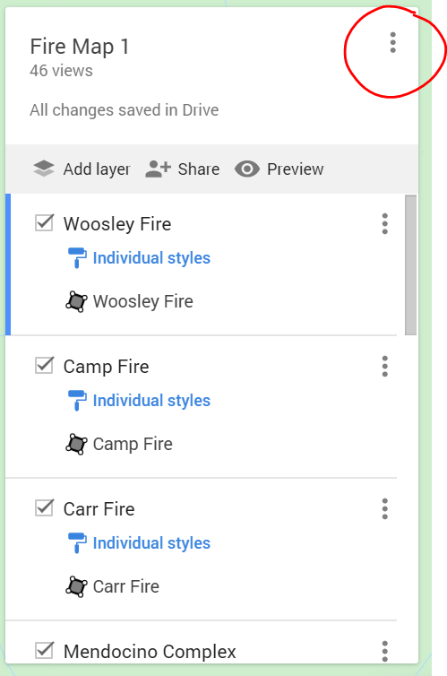

1. Select export to KML/KMZ
   1. KMZ works best

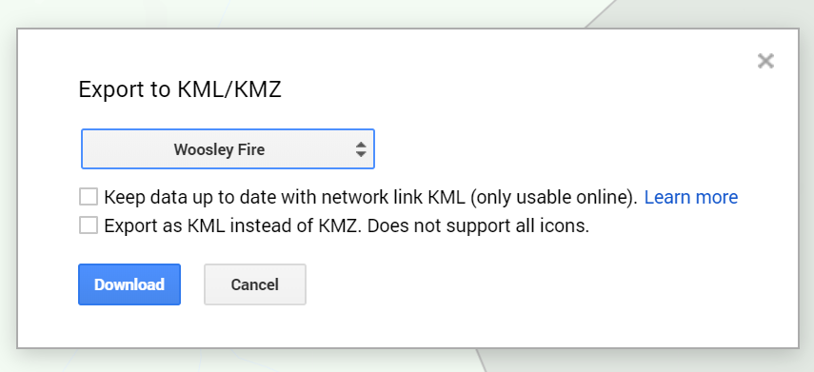

1. Select each Fire individually and download